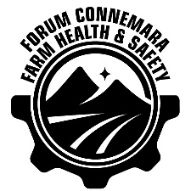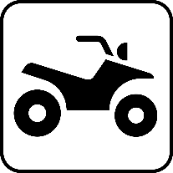

FORUM CONNEMARA FARM HEALTH & SAFETY FARM ACTION PLAN

Farm Inspections & Risk Assessment
Farm inspections will be completed annually or as needed as changes are made to the farm, and also as part of daily work, to ensure that any new hazards are identified and that existing ones continue to be controlled effectively. This will involve a tour of the farm and all machinery looking for the following:
- Any new hazards that have the potential to cause serious or major harm
- Any hazard controls that aren’t working
Once the inspection is completed, any necessary actions will be noted on the risk register below and appropriate actions taken and communicated to others as required.
When implementing this plan, we will identify those hazards on the property that have the potential to cause harm. The level of risk posed by each hazard will then be assessed using the table below. This will determine:
- The likelihood of the hazard causing a person harm
- The severity of the consequences if the hazard does cause harm
Risk = Likelihood x Consequence
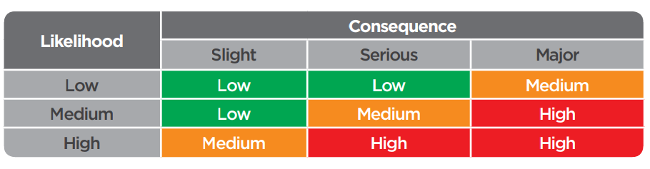
Those hazards assessed as being high risk and of an on-going nature (e.g. hazardous substances) will be documented in the following Risk Register. The control measures to be applied to reduce the level of risk to an acceptable level (medium or low) will also be documented in the Risk Register. Decisions on the appropriate control measures to be applied will be based on the following considerations:
- Can the risk be eliminated (e.g. negotiating steep terrain by foot instead of quad bike)
- If the risk can’t be eliminated, can it be minimised?
The Risk Register documents the hazards and associated risks on the farm and applies specific controls to eliminate or minimise those risks.

Farm Inspection Risk Register

Risk identified | Likelihood  Low/Medium/High | Consequence  Slight/ Serious/ Major | Action to mitigate | Date Completed

